WEATHER APP
AIM: Electric vehicles (EVs) will be effortlessly incorporated into the transportation system, as transportation electrification is one of the fundamental components in future smart city design. Charging stations are the primary source of energy for electric vehicles, and their location is crucial for EV accessibility in cities. They should be strategically placed so that an electric vehicle may access a charging station within its driving range and then travel around the city once charged. We propose the Electric Vehicle Charging Slot Booking in this work, in which we try to reduce the EV charging station queue. The proposed EV Charging mobile app system will give EV car owners the convenience of discovering charging stations on a Google map, as well as charging slot availability. Receive charging status updates Assist in making EV charging stations more accessible and ensuring seamless long-distance travel.
IMPLEMENTATION:
- Created this app project using,
- Html for structuring the app.
- CSS for layput and styling
- Javascript for integrating and for ffetching weather data and firebase.

- The app displays the details such as,
- Home page
- Navigator page
- Stations
- Nearby stations
- Current location identifier

- Basic features included,
- User interface: Designed a clean and intuitive user interface for the electric vehicle recharge bunk. It includes options such as finding nearby stations, loacting stations and appointmnent.
SCREENSHOTS:
- HOME PAGE:

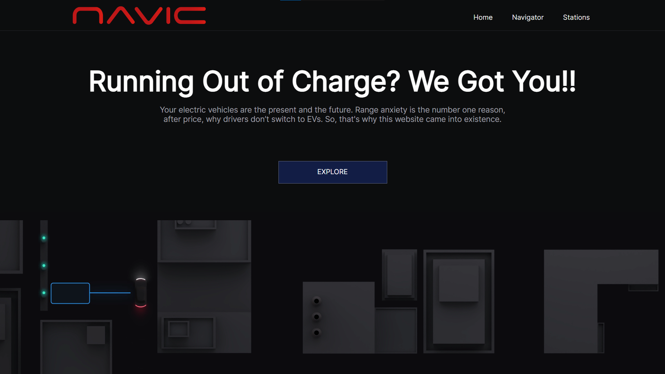

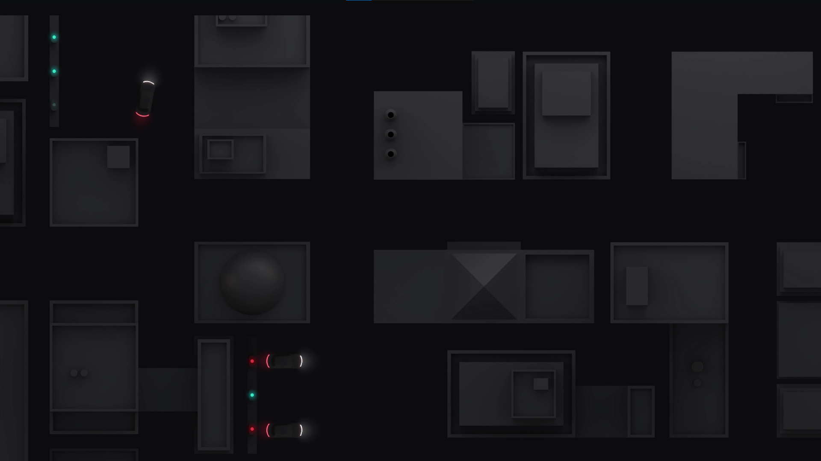

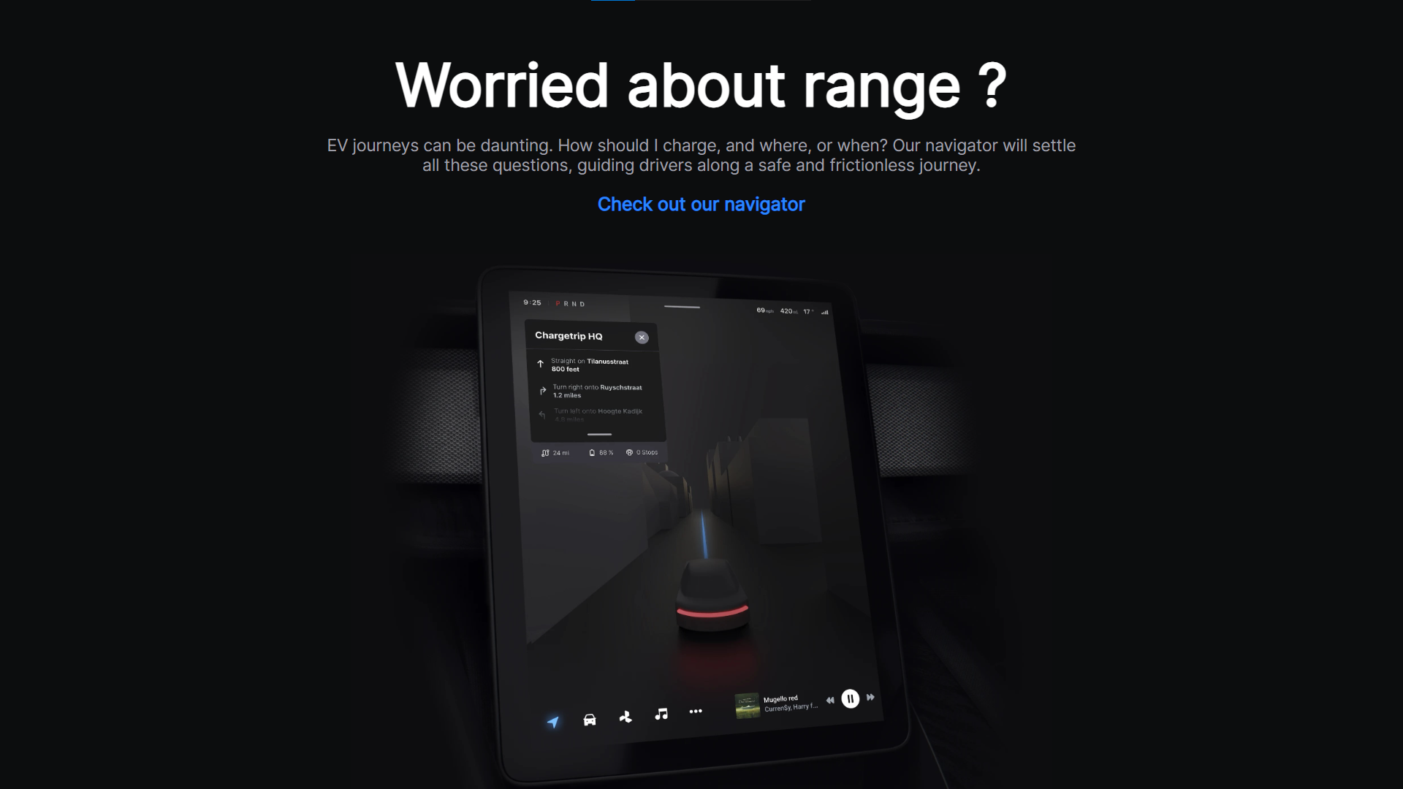

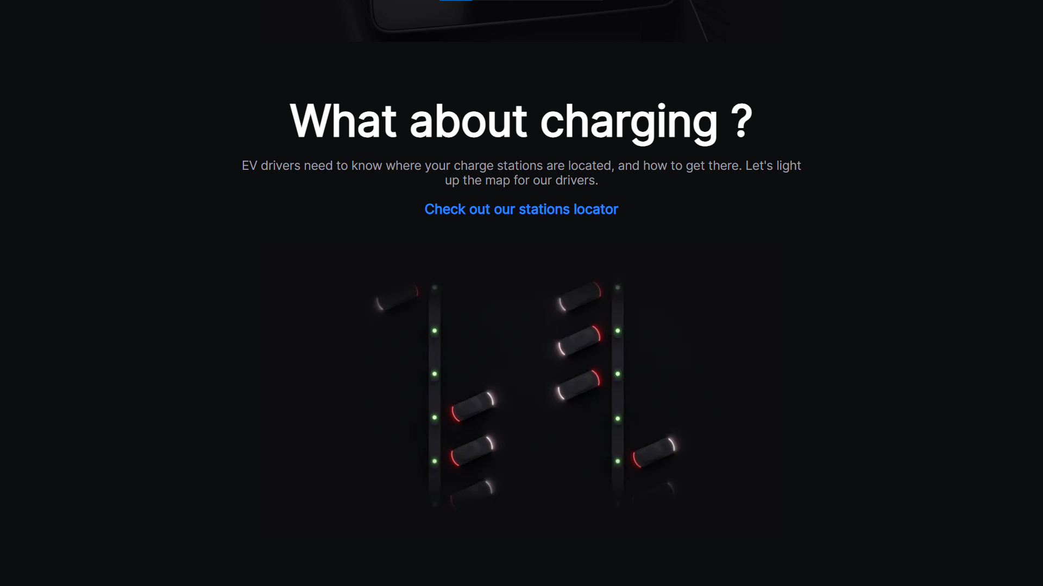

- NAVIGATOR PAGE:
CURRENT LOCATION IDENTIFY:
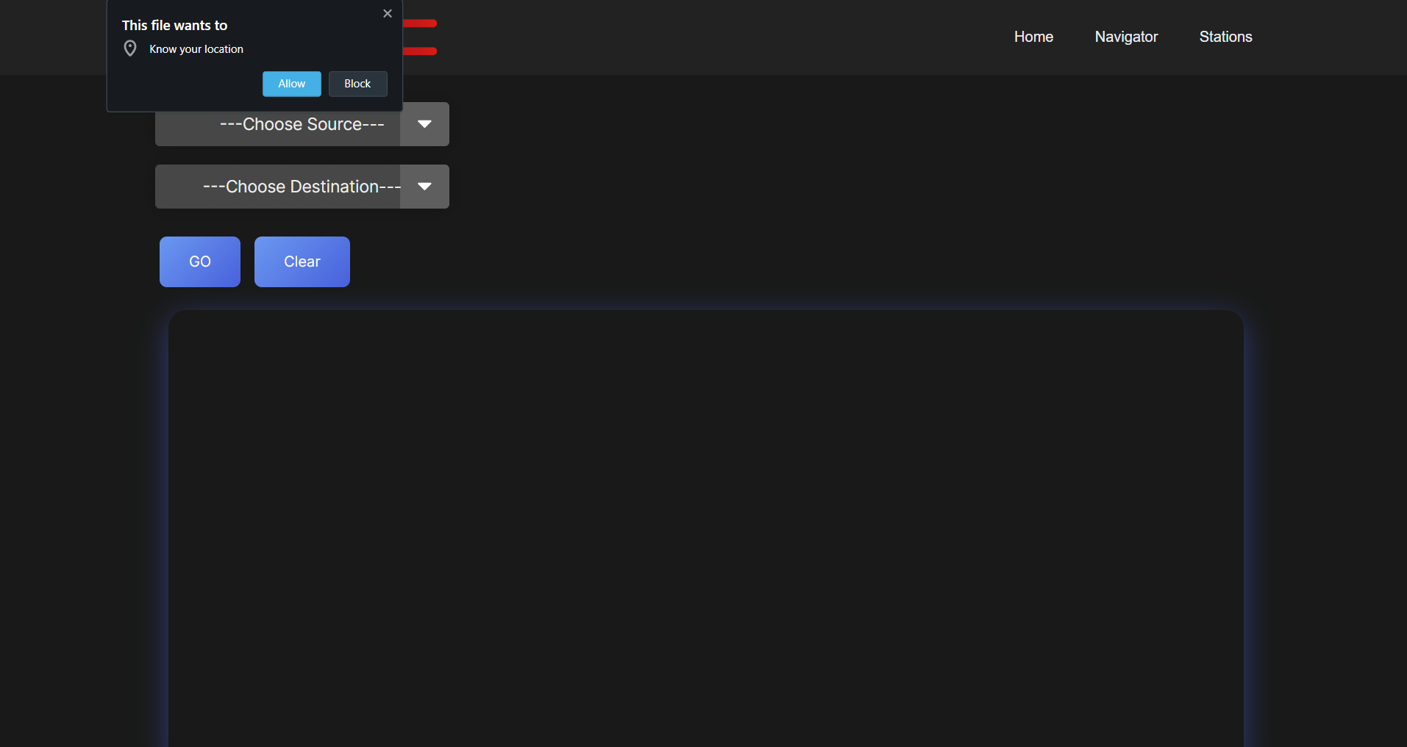
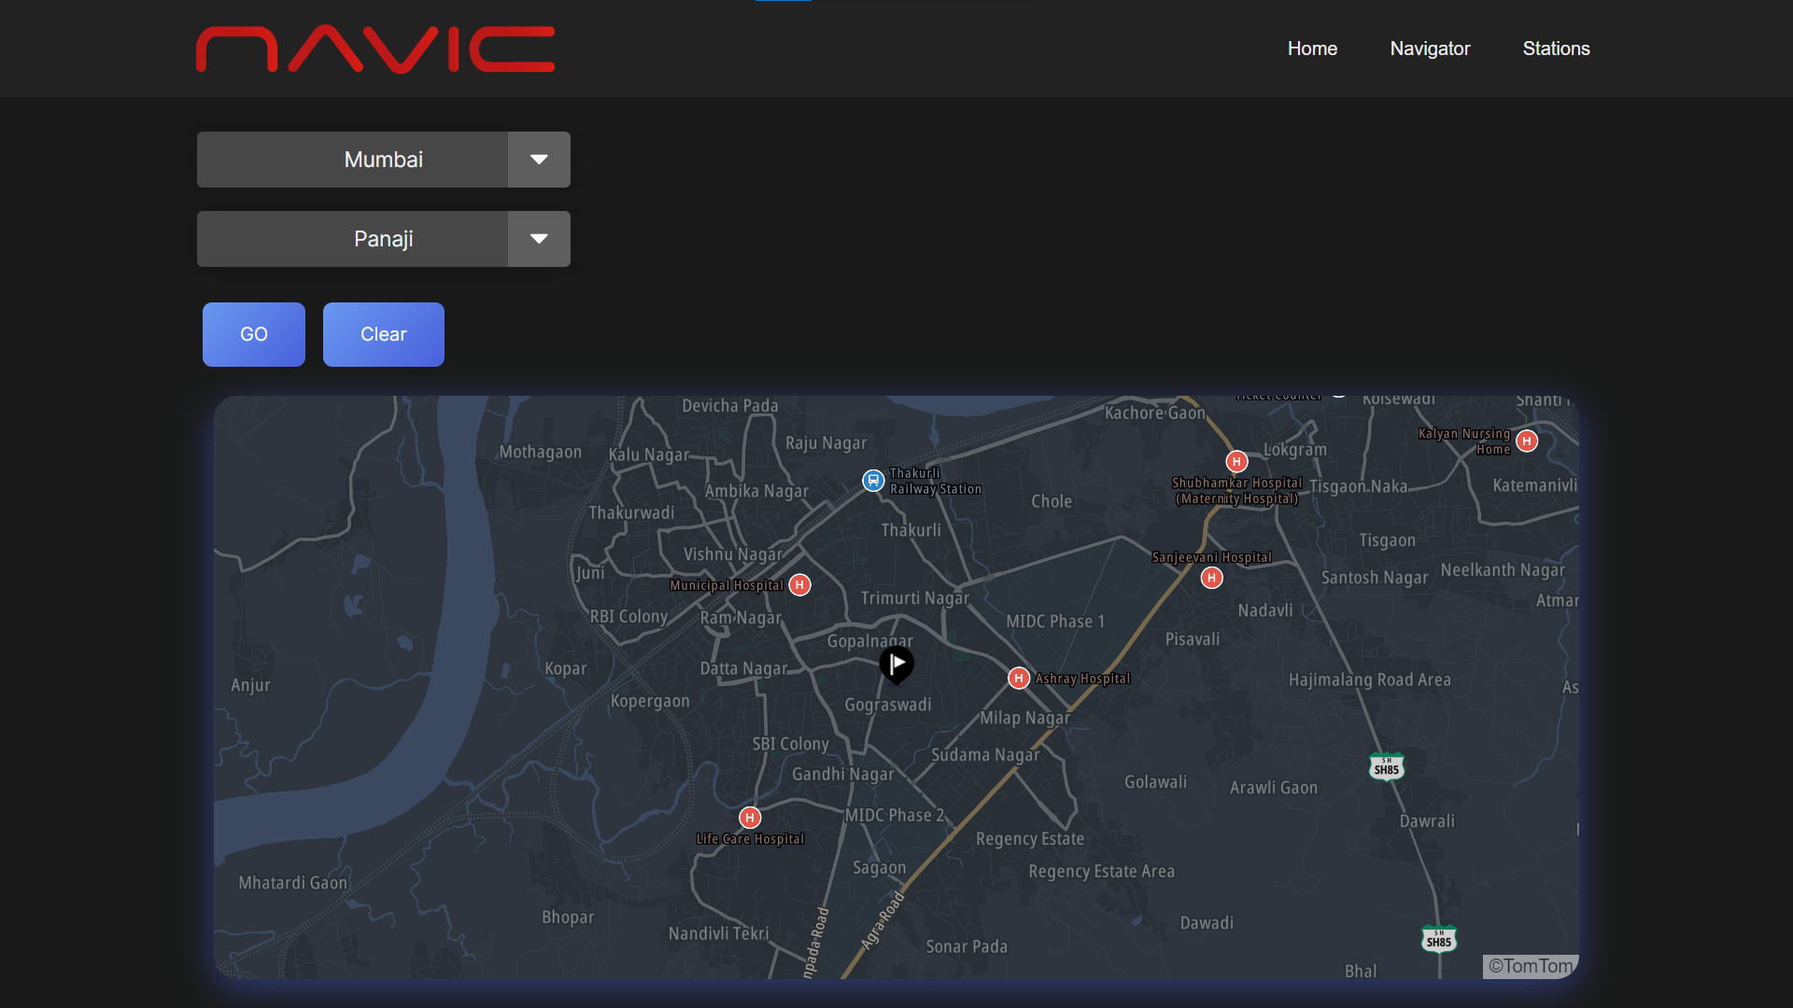

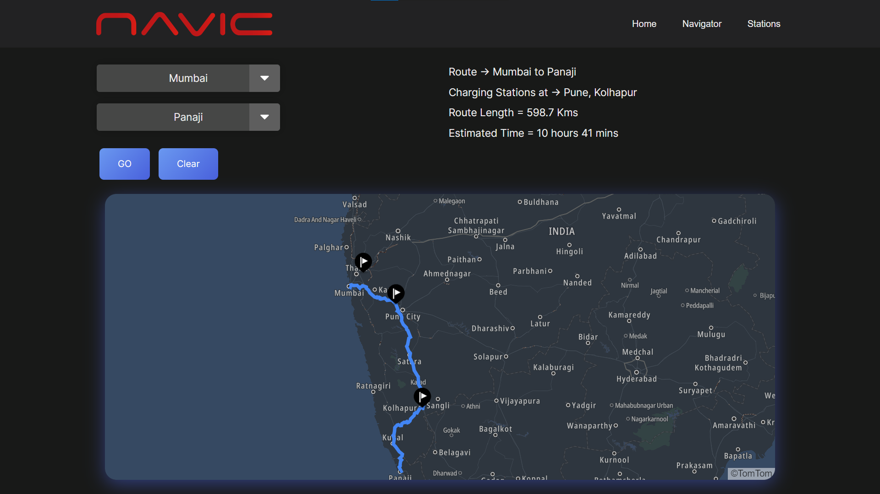

- STATIONS FINDER PAGE:

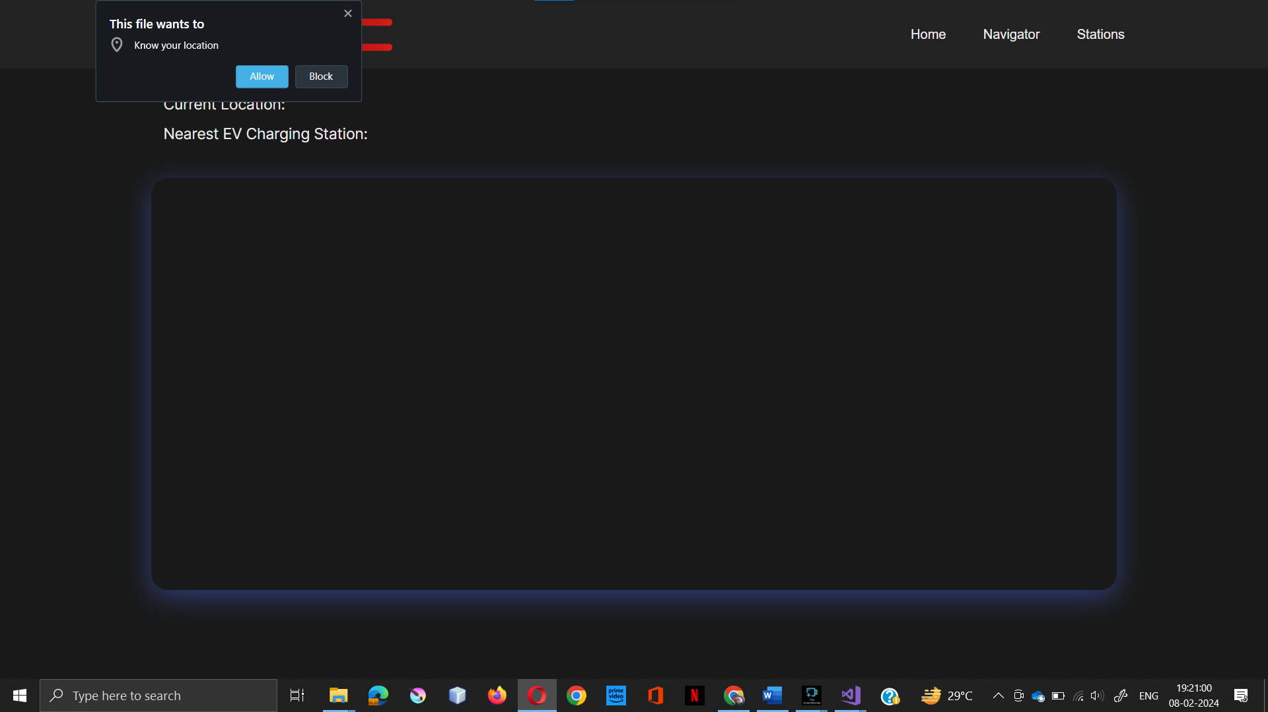

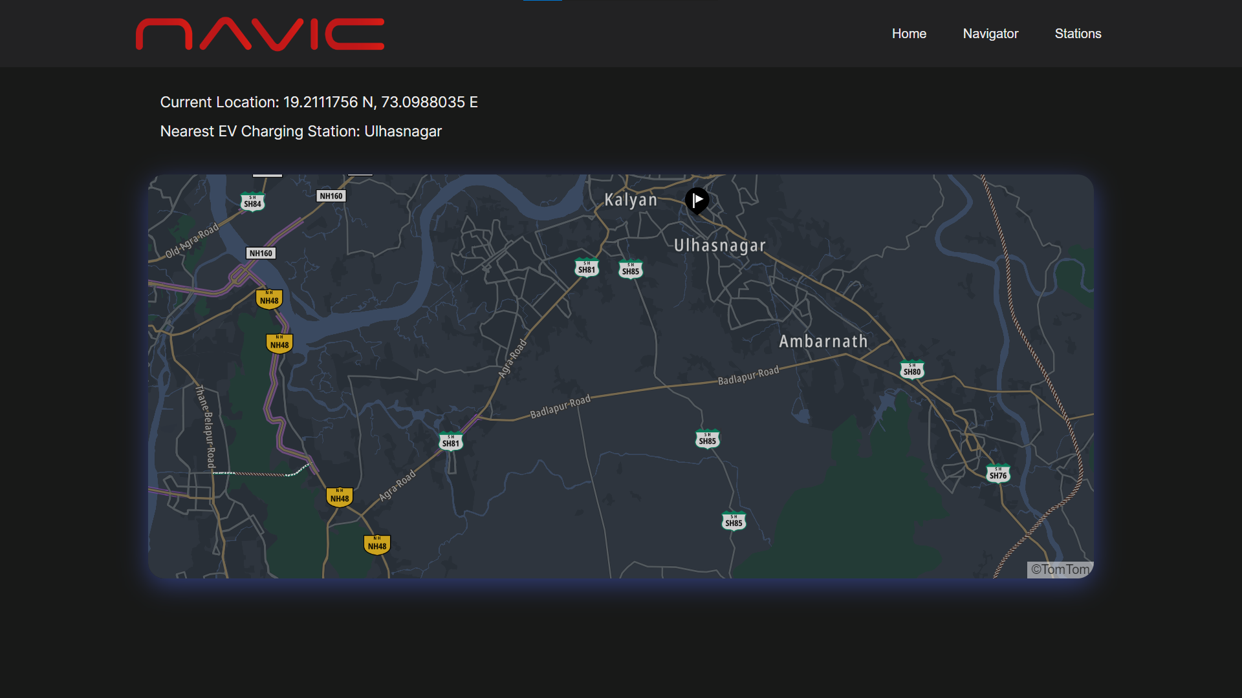

GUIDE TO OPEN THE PROJECT:
- Extract the EV-recaharge-bunk.zip file from the given drive link into your device.
- After extracting open the EV-rrecharge-bunk folder in your device and run the index.html in your preferred browser or default browser.

